INTERNSHIP REPORT

TITLE PAGE
TECHNOLOGY PROJECT: TO-DO LIST
Submitted in partial fulfillment of the requirements
for the award of the degree of
FYUGP – Bachelor of Science (Computer Science)
Submitted by
Name: PRANAV PRAVEEN
Course: FYUGP B.Sc. Computer Science
Register no: PNAYSCS026
College: PRAJYOTI NIKETAN COLLEGE PUDUKAD
University: CALICUT UNIVERSITY
Internship Organization:
ZIUKE INFOTECH THRISSUR
Internship Duration:
60 Hours (Company Training Internship)
Project Title:
ONLINE FOOD ORDERING
Technology Used:
Python, Django, HTML, CSS
Academic Year: 2024-27
Submitted to
Prajyoti Niketan college pudukad

ACKNOWLEDGEMENT

I express my sincere gratitude to ZIUKE INFOTECH THRISSUR for providing me with the opportunity to undergo a 60-hour company training internship as part of the FYUGP B.Sc. Computer Science curriculum. This internship helped me gain practical exposure to real-world applications of computer science concepts.
I would like to extend my heartfelt thanks to my internship trainer and coordinators for their valuable guidance, continuous support, and encouragement throughout the training period. Their technical insights and mentoring helped me understand web development concepts more effectively.
I am also grateful to the faculty members of the Department of Computer Science, prajyoti Niketan college pudukad, for their academic guidance and motivation. Finally, I thank my parents and friends for their constant support, which contributed to the successful completion of this internship.

EXECUTIVE SUMMARY

This internship report presents a detailed account of the company training internship completed at ZIUKE INFOTECH THRISSUR for a duration of 60 hours, as required by the FYUGP B.Sc. Computer Science program. The primary objective of the internship was to gain practical knowledge in web development and understand professional working environments.
During the internship, training was provided in Python programming, Django web framework, and frontend technologies such as HTML and CSS. A To-Do List Application was used as a learning-based application to demonstrate how real-world web applications are designed, developed, and managed.
The internship enhanced my technical knowledge, improved problem-solving skills, and provided exposure to industry-level development practices. This report includes details about the organization, internship overview, internship experience, learning reflections, and outcomes achieved during the training period.

CERTIFICATE .

TABLE OF CONTENTS

- Organization Profile…………………………………………………………6
- Internship Overview…………………………………………………………7
- Internship Experience………………………………………………………..8
- Learning Reflection…………………………………………………………10
- Appendix…………………………………………………………………….11

CHAPTER 1: ORGANIZATION PROFILE

1.1 Introduction to the Organization
Ziuke is a professional organization that specializes in providing technical training and internship programs for students in the field of information technology. The organization focuses on skill development through practical training and real-time application exposure.
The organization aims to prepare students for the IT industry by offering structured training modules aligned with current industry standards.

1.2 Vision
To empower students with practical technical skills and prepare them for successful careers in the information technology sector.

1.3 Mission
- To provide industry-relevant technical training
- To enhance practical knowledge and coding skills
- To bridge the gap between academic learning and professional requirements

1.4 Services Offered
- Company-based technical training programs
- Internship opportunities for students
- Web development training
- Programming language training
- Skill enhancement workshops

1.5 Organizational Structure
The organization follows a systematic structure consisting of:
- Training Manager
- Technical Trainers
- Internship Coordinators
- Interns and Trainees
This structure ensures smooth coordination and effective delivery of training programs.

CHAPTER 2: INTERNSHIP OVERVIEW

2.1 Internship Details
- Type: Company Training Internship
- Duration: 60 Hours
- Course: FYUGP B.Sc. Computer Science
- Project: To-Do List
- Technologies Used: Python, Django, HTML, CSS

2.2 Objectives of the Internship
The objectives of the internship were:
- To gain hands-on experience in web development
- To understand backend and frontend interaction
- To learn Python programming concepts
- To explore Django framework fundamentals
- To understand professional work culture

2.3 Internship Structure and Schedule
The internship was divided into the following phases:
- Introduction to Python programming
- Basics of web technologies
- Django framework concepts
- Application-based practical training
- Review and evaluation
Each phase was designed to gradually enhance technical understanding.

2.4 Tools and Technologies Used
- Python: Backend programming
- Django: Web framework for application development
- HTML: Structure of web pages
- CSS: Styling and layout

CHAPTER 3: INTERNSHIP EXPERIENCE
Project: To-Do List

3.1 Introduction
A To-Do List application is a simple task management system developed using Python Django that helps users organize their daily activities efficiently. This application allows users to add, view, update, and delete tasks on a daily basis, making it easier to track pending work and improve productivity. Django provides a secure and structured framework for building this web-based application
3.2 Purpose of the Application
The main purpose of the To-Do List was to:
- Help users manage daily tasks effectively
- Provide a simple platform for adding and deleting tasks
- Improve time management and productivity
- Reduce the chances of forgetting important tasks
- Practice and implement Django concepts in a real-world project

3.3 Features of the Application
- Add new tasks for daily activities
- Delete completed or unwanted tasks
- View all tasks in an organized list
- Simple and user-friendly interface
- Web-based application accessible through a browser
- Built using Python Django framework

3.4 Backend Development Experience
Using Python and Django, I learned:
- How to create models for storing data
- How to handle user requests and responses
- How to use views and templates
- How Django follows the Model-View-Template (MVT) architecture

3.5 Frontend Development Experience
Using HTML and CSS, I gained experience in:
- Designing structured web pages
- Creating forms and layouts
- Improving visual appearance
- Integrating frontend with backend

3.6 Challenges Faced During Internship
- Understanding Django concepts initially
- Debugging errors during development
- Integrating backend logic with frontend design
These challenges were resolved through continuous practice and trainer guidance.

3.7 Overall Internship Experience
The internship provided valuable exposure to real-world development practices and helped strengthen my technical foundation.

CHAPTER 4: LEARNING REFLECTION

4.1 Technical Skills Acquired
- Python programming skills
- Django framework fundamentals
- Web application development
- Frontend and backend integration

4.2 Professional Skills Acquired
- Time management
- Communication skills
- Problem-solving ability
- Teamwork and discipline

4.3 Academic and Career Benefits
The internship enhanced my understanding of computer science concepts and provided clarity regarding career opportunities in web development and software development.

4.4 Overall Reflection
The internship was a valuable learning experience that improved both my technical competence and personal growth. It helped me understand industry expectations and prepared me for future academic and professional challenges.

APPENDIX

Internship Completion Certificate (Attached)
Internship Duration: 60 Hours
Organization: ZIUKE INFOTECH THRISSUR
Project title: To-Do List
Technologies Used: Python, Django, HTML, CSS
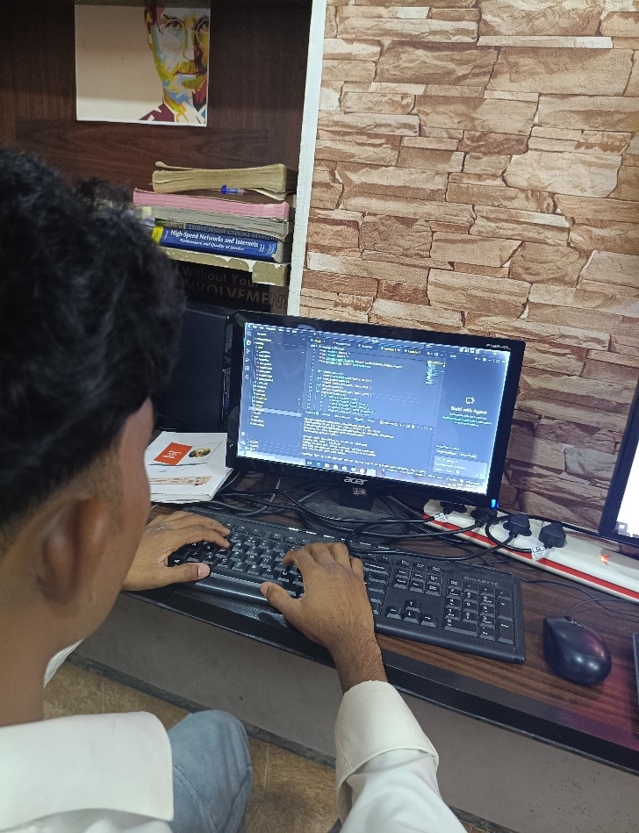
Worksheet
click here

